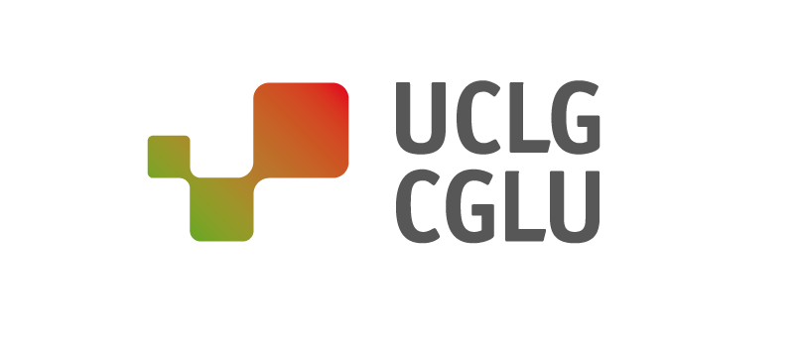
Barcelona, 16 September 2019
PRESS RELEASE: Cities take seats at the global table

Local governments at the UN High Level Week: Localization, key to accelerating global agendas

From 23 to 27 September, the United Nations General Assembly's High-Level Week will be held in New York, marking the quadrennial review of the Sustainable Development Goals.

The second Forum of Local and Regional Governments, which will take place on 24 September, will be the key moment of the week for local and regional leaders.

In the framework of the opening of the 74th session of the UN General Assembly on 17 September, and the celebration of the high-level week from Monday 23 to Friday 27, local and regional governments take a seat at the global table to demand the value of public services and the role they themselves play in carrying them out, which is essential to promote the localization of global agendas.

At the centre of the agenda will be action for climate and sustainable development, which will take the form of the Climate Action Summit (23 September) and the SDG Summit (24-25 September). The main space for dialogue between local leaders and national governments will be the second Forum of Local and Regional Governments (September 24, 15-18h). Cities and regions will also have a prominent place in the preparatory meetings for the Climate Summit, during the previous weekend (21 and 22 September).

Achieving the SDGs, the key to collaborative climate action that leaves no one behind

Local and regional governments share the United Nations vision of the need to accelerate action on implementation. In this regard, they will demand greater attention to receiving support for local public services on which more than 65% of the ODS targets depend. Only by increasing local public investment, which currently accounts for less than 10% of investment, and with adequate and shared financing of infrastructure will it be possible to achieve the ambitious, inclusive and just goals that can help us face the climate emergency and inequality that affect our planet.

It is therefore essential that all the global agendas be addressed as one, for only if we achieve the SDGs will we be able to fulfil agendas as ambitious as the Paris Agreement. At the Climate Action Summit, convened by UN Secretary General Antonio Guterres on 23 September, it is hoped that the commitment to the Paris Agreement will be strengthened and that actions to combat climate change will be accelerated with emergency measures in all territories.

Let's take local and regional action to the next level!

On Tuesday 24 September, the SDGs Summit opens at the General Assembly to review progress on the implementation of Agenda 2030. Within this framework, the second Forum of Local and Regional Governments, organized by the United Nations Department of Economic and Social Affairs, UN-Habitat and Local 2030 and the Global Taskforce of Local and Regional Governments, will take place.

"For our collective of local and regional governments, the ODS are more than a list of objectives: they represent an opportunity to renew the social contract and to achieve all the ambitious global agendas”, President of UCLG, Parks Tau.

On the premise of the Seville Commitment, the consolidation of the Forum of Local and Regional Governments will be key to establishing a space for dialogue between local governments, states and the United Nations system that participate in the definition, implementation and monitoring of global agendas. The declaration, the result of the conversations, will deploy strategic coordination actions among the different spheres of government in the next decade of implementation.

Recognizing local and regional leaders as key actors in global decision-making

On the 2nd day of the SDG Summit (25 September), local and regional governments will once again raise their voices by bringing their message, actions and commitments to other political actors and public opinion in a High-Level Dialogue between leaders on the location of Agenda 2030. It is worth noting the clear recognition that the Political Declaration that will result from the Summit makes of the role of local and regional governments in achieving this agenda.

Other meetings such as the High-Level Dialogue on Financing for Development, which will take place on 26 September, will be important to discuss the resources and capacities needed to be able to implement also in cities and regions and not only at the national level.

We've started a race against the clock that we can and must win. This will not be possible without the renewal of mechanisms for a new multi-level governance. Cities and regions of the world are ready to enter the decade of implementation for Agenda 2030.
------
About UCLG:
United Cities and Local Governments (UCLG) is the global organization of local and regional governments and their associations that represents and defends their interests on the world stage. Representing 70% of the world's population, UCLG members are present in all world regions: Africa, Asia Pacific, Europe, Eurasia, Middle East-West Asia, Latin America and North America - organised in seven continental sections, a metropolitan section and a regional forum. This network covers more than 240,000 cities, regions and metropolises and more than 175 local and regional government associations present in 140 countries. UCLG includes among its main areas of political interest local democracy, climate change and environmental protection, the achievement of Sustainable Development Goals, local finance, urban development and city diplomacy for peacebuilding.

----CONTACT :
United Cities and Local Governments / Address C/Avinyo, 15 08003 Barcelona
+34 93 342 87 / Email communication@uclg.org / Redes sociales @uclg_org #Listen2Cities #HLPF2019 / Web www.uclg.org

